# Stage 1: Reading and writing data to and from files
def read_from_file(filename):
# Enter your code here
file = open(filename,'r')
readFile = file.read()
fileList = readFile.split('\n')
numberList = []
for line in fileList:
if (line == '-' or line == ''):
continue
numberList.append(float(line))
file.close()
return numberList

def write_to_file(filename, binned_data):
file = open(filename, 'w')
for key,value in binned_data.items():
file.write(str(key) + ": "+str(value)+"\n")
file.close()

def get_binned_data_template(bin_min,bin_max,binsize):
current_low = bin_min
binned_data = {}
while current_low < bin_max:
binned_data[str(current_low)+ ' - ' + str(current_low+binsize)] = 0
current_low+=binsize
return binned_data
# Stage 2: Place the data into bins
def bin_data(data, binsize):
# Enter your code here
bin_min = min(data)
bin_max = max(data)
binned_data = get_binned_data_template(bin_min, bin_max, binsize)
for value in data:
low = bin_min
while low <= value-binsize:
low += binsize
binned_data[str(low)+ ' - ' + str(low+binsize)]+=1
return binned_data

# Stage 3: Display the frequency analysis
def display_freq_analysis(binned_data):
# Enter your code here
# print("here",binned_data)
for key,value in binned_data.items():
print(str(key) + ": "+str(value))

def save_function(data, binned_data):
option = input("Save analysis to file (Y/N) ")
if option != 'Y' and option!= 'N':
print("Not a valid option")
save_function(data, binned_data)
elif option == 'Y':
name = input("Enter file name: ")
write_to_file(name, binned_data)
choices(data)

def choices(data):
global binsize_global, binned_data_global
print("1. Set bin size \n2. Display frequency analysis \n3. Exit")
choice = input("Please enter your choice: ")
if choice == '1':
binsize_global = input("Enter bin size: ")
binned_data_global = bin_data(data,float(binsize_global))
choices(data)
elif choice == '2':
if binsize_global == "null":
print("Please set a bin size first\n")
choices(data)
display_freq_analysis(binned_data_global)
save_function(data, binned_data_global)
elif choice == '3':
exit(0)
else:
print("Not a valid option")
choices(data)

def start():
filename = input("Enter data file: ")
try:
data = read_from_file(filename)
choices(data)
except FileNotFoundError:
print("File not available\n")
start()
return

# Stages 4 and 5: Interact with the user with menus and error handling.
# The following line suppresses the code when the file is imported
if __name__ == '__main__':

# Enter your code here (indented)
binsize_global = "null"
binned_data_global = {}
start()

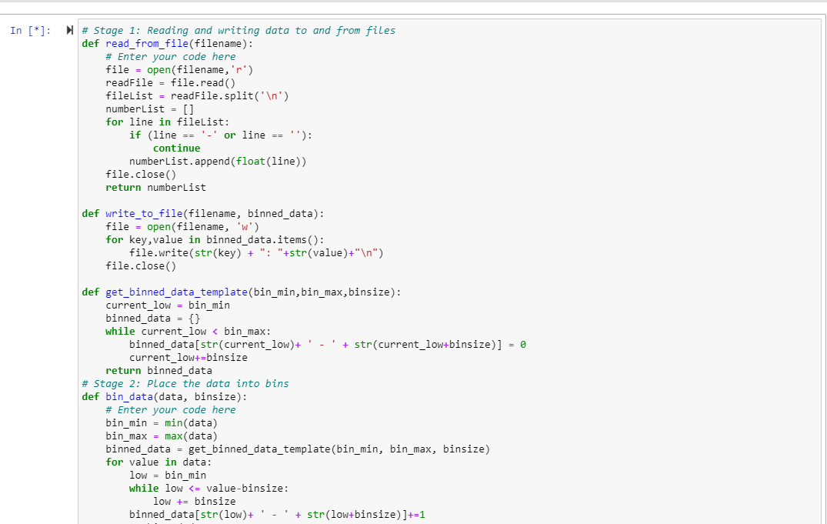
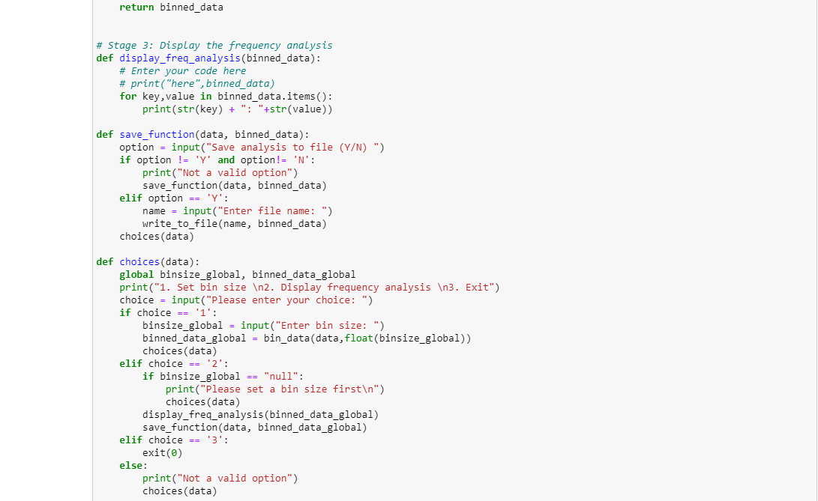
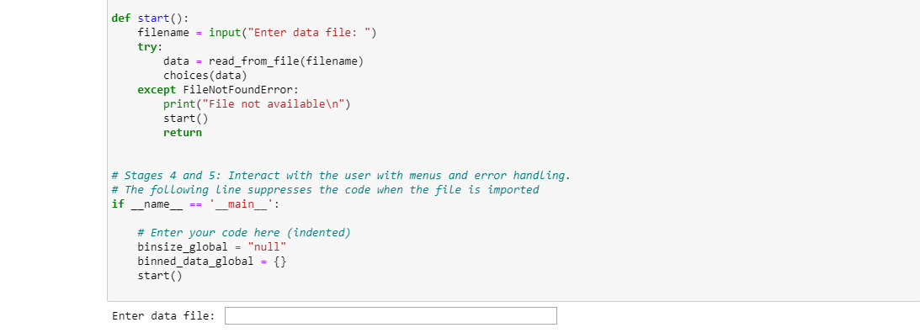

Code asks user to enter file name (data03.txt as provided) then enter 3 choices where input is requested (1, 2, 3) which looks like this after entering file name (parts I entered are in yellow):

Enter data file: data03.txt
1. Set bin size
2. Display frequency analysis
3. Exit
Please enter your choice: 1
Enter bin size: 5
1. Set bin size
2. Display frequency analysis
3. Exit
Please enter your choice: 2
-0.1 - 4.9: 9
4.9 - 9.9: 1
Save analysis to file (Y/N) n
Not a valid option
Save analysis to file (Y/N) N
1. Set bin size
2. Display frequency analysis
3. Exit
Please enter your choice: 3

